Harvesting Hope: César Chávez
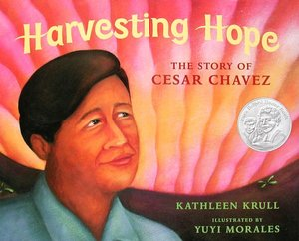 | Vocabulary from Text  *** | Synonym  ** | Synonym  * | Antonym | translation
 | boycott  (verb) | avoid | don’t use/buy/etc. | support
 | nonviolent  (adjective) | passive | peaceful | violent
 | harvesting  (verb) | reaping | picking | planting
 | courage  (noun) | valor | bravery | fear
Content Words:
strike, labor union, migrant, civil rights,

Phrases of the week:
I am fed up with _______________________.
It takes courage to ____________________.
I hope __________________.

